SPORTS GALA 2025
LAHORE UET (CS DEPARTMENT)
GEAR UP FOR MOST EXCITING EVENT
WELCOME TO ALL
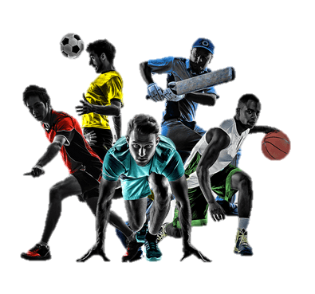
28th Oct,2025
Junaid Jamshed Stadium

